Updating Robot C

# **Description**

This tutorial is a guide for updating ROBOT C on the Vex IQ laptops

# **Instructions**

## **Log into Laptops**

1. Take a laptop for your team from the Vex IQ laptop cart
2. Power on and log into the laptop
   1. Login: Student
   2. Password: obfuscate

## **Opening Robot C**

1. Look on the desktop for the Robot C icon. Select the “RobotC for Vex Robotics”  
   Do not open the “Graphical ROBOTC” program  
   1. 
2. In the program menu bar, select **Help --> Check for Updates**  
   1. 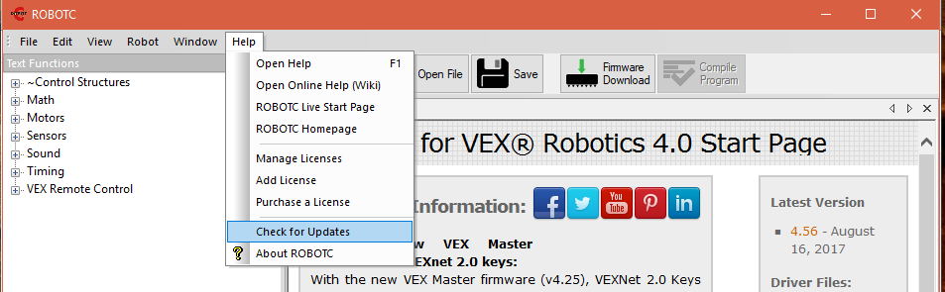
3. A prompt will appear. If the prompt reads “Everything is up to date!”, Robot C is updated  
   1. 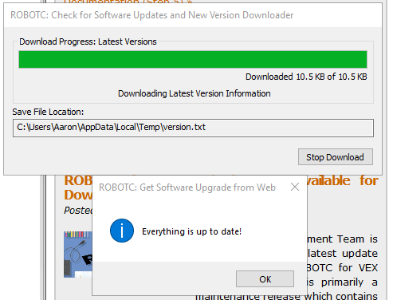
4. If the prompt does not state “Everything is up to date!”, follow the on-screen instructions to complete the update. Accept all permissions and allow the full installation.